WHY IS FORECASTING USEFUL OR NECESSARY?

Businesses need to plan for the future.

This is true for all types of business.

To do this (i.e. plan) requires some idea about what the future will be.

SOME EXAMPLES:

- Obtaining finance: a business plan

- Inventory levels: depends on sales expectations

- University enrolment: what grades should SBS require in making offers of places

- Hospitals: how many hospitals/beds/doctors/nurses are needed?
HOW CAN WE FORM VIEWS ABOUT WHAT THE FUTURE WILL BE LIKE?

Method 1: ROULETTE

Assume that the future will be the outcome of a pure chance process, and so is inherently unpredictable.

May be appropriate in some circumstances:
- a syndicate regularly betting on the national lottery
- casino gambling

But does not seem to be appropriate in most areas of business life.

Method 2: OSTRICH

Assume that the future will be identical to the present (nothing changes).

When might this be appropriate?

- To stone age humans
- To medieval peasants
- To dinosaurs
- In some special circumstances today?
Example: Inflation rate, given a commitment by the Bank of England that inflation will be set at 3% per year.
But it is dangerous to behave like this: things often do change!

Method 3: TRENDY

Assume that the past contains patterns or trends that will continue into the future.

Views about the future formed by identifying trends and projecting them forwards in time.

Examples:

- The value of a bank deposit over time
- Population trends
- Level of demand for mobile phones

Method 4: MAD SCIENTIST

Find a (correct) theoretical cause and effect model: use knowable changes in causes to predict changes in effects.

Examples:

- Position of spaceship at different points in time, given settings pre-determined by NASA

- Inflation rates, given money supply growth rates announced in advance by Bank of England.

- How many of a particular car model will you sell per year at £11,000, £12,000 and £13,000?

Method 5: KALEIDOSCOPE

Develop a set of scenarios that are plausible stories that could be told about the future, knowing all that you do right now.

Keep all of these in mind. Evaluate your possible options against each of these.

Examples:

- Possibility of nuclear war

- Consequences of global warming

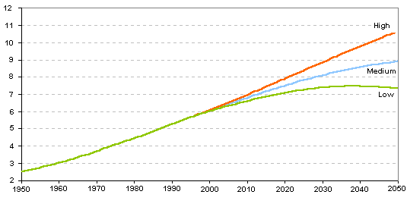
HERE ARE THE METHODS AGAIN

Method 1: ROULETTE
Method 2: OSTRICH
Method 3: TRENDY
Method 4: MAD SCIENTIST
Method 5: KALEIDOSCOPE

WHICH MIGHT BE APPROPRIATE FOR THE FOLLOWING?

- The time of the next high tide

- Next number in the sequence 2,2,2,2,2,

- How many people in the UK will have internet access at home next year?

- What class of degree will you get?

WHAT COMES IN LATER PLENARIES?

Method 3: TRENDY
Our main focus this semester; the only one we expect you to use in second group tasks (but you might choose to use another)

Method 4: MAD SCIENTIST
A little on this later in this block. More on it next semester

THE SECOND GROUP PROBLEM

Each group should:

- Select three series

- Develop a business context for each of the selected series:

- What kind of business will find it useful to forecast this?
- How and why might forecasts be useful?
- How could the forecasts be made?
- What might be the limitations of these forecasts?
- Any other matters you feel are relevant.

- Forecast the value of each of these series for the next four periods ahead.

- Each group to give an oral presentation

Bear in mind the following points in selecting the three variables:

- We want your three selected series to show a range of different properties.
e.g.
Package 1:
- a series with no upward or downward trend
- a series with an upward trend
- a series with strong seasonal variations

Package 2:
- a series with one or more sharp changes at particular points in time
- a series that shows exponential growth
- a series that shows no simple pattern at all

- At least one of the series you choose should be forecast using a moving average procedure.

DATA TO SELECT AND USE

Possibilities include:

- road traffic demand/numbers of cars
- road traffic accident deaths and/or serious injuries
- student numbers in higher education
- demand for hospital beds
- airline passenger demand
- violent crime rates
- interest rates
- population
- consumption of oil, gas, …

Where can you find the data?

Three possibilities:

- On the Integrative Studies web pages (see “Materials”)

- From the StatStore database (http://www.statistics.gov.uk/statbase/datasets.asp or via the link StatStore datasets ).

- Elsewhere on the internet, from a library, or from some other source.

